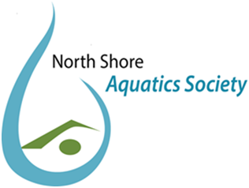

NORTH SHORE AQUATICS SOCIETY
Society # S-0060633
Email: nsaquatic.society@gmail.com

REGISTRATION
Date: _______________________________
Corporation: ______________________________
SURNAME: _________________________________
M/F:
FIRST NAME:
BIRTHDATE:
(
DD/MM/YY)
ADDRESS:
CITY:
POSTAL CODE:
PHONE:
E-MAIL: ________________________________________
(required for all registrants - email addresses will not be shared)

The North Shore Aquatics Society collects and uses your personal information for the purposes of registration, administration and functions of the Society.
The Society's Policy and Procedures adhere to the requirements o the Personal Information Protection Act of BC.
It is a requirement of registration that the information be provided and that it will only be used for the purposes indicated. By your signature on this form you signify
your consent to the collection and use of your personal information in accordance with the Society's Privacy Policy.
SIGNATURE
Registrant or Club/Group Representative:
Position with Club/Group:
DATE :
***Fees must be paid at the time of registration***
Payment = $60 (Corporations group/club registration); individual registration FREE

Payment should be made to: North Shore Aquatics Society
Mail address: 4025 Mt Seymour Parkway, North Vancouver, BC. V7G 1Z8

Donations: $5 $10 $20
Support the Vision Visionupport the Vision

